AWARDS
FACULTY ACHEIVEMENTS
We are delighted to celebrate the outstanding accomplishments of the Department of Oral Medicine and Radiology, Faculty of Dental Sciences, SGT University.
Dr. Puneeta Vohra (Professor & Head) has been honoured with the Best Academician of the Year (Below 45 Years) award, and Dr. Priyanka (Assistant Professor) has been recognized as the Best Budding Oral Medicine and Radiologist of the Year at the National Dentist Awards 2025.
Adding to this pride, they secured 1st and 2nd positions in the Scientific Paper Presentation at the 18th World Dental Sciences and Oral Health Conference, held at Nair Hospital Dental College, Mumbai.
These prestigious achievements reflect their exemplary academic leadership, research excellence, and unwavering commitment to advancing the field of Oral Medicine and Radiology, under the inspiring guidance of Dean Dr. Omkar Shetty.
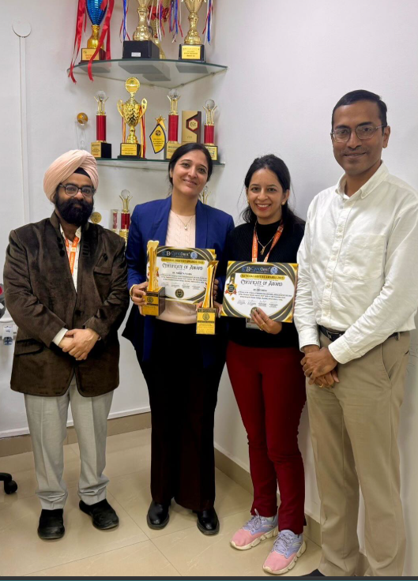

STUDENTS ACHEIVEMENTS

S.NO | NAME | YEAR | CONFERENCE | POSITION
1. | Dr Pinki | 2nd year | FROM BIOPSY TO BYTES: AI IN ORAL CANCER DETECTION  23rd National Triple O symposium 2026 – ITS dental college | 1st Position  POSTER
2. | Dr Sneha | 2nd year | A SYSTEMATIC REVIEW OF APREMILAST IN ORAL LICHEN PLANUS  23rd National Triple O symposium 2026 – ITS dental college | 2nd Position  PAPER
3. | Dr Yashna | 2nd year | EXPLAINABLE AI IN ORAL RADIOLOGY: OPENING THE BLACK BOX  International conference on developments in emerging new technologies for advanced lifelong oral care, organized by AadGrow Foundation 2026. | Best Presentation  PAPER
4. | Dr Reecha | 1st year | SYSTEMIC REVIEW OF REGENERATIVE THERAPIES IN MANAGEMENT OF TEMPOROMANDIBULAR DISORDERS  23rd National Triple O symposium 2026 – ITS dental college | ^{2nd} Position  PAPER
5. | Dr Sumridhi | 3rd year | PHONOPHORESIS – THE REMEDIAL SOUND IN REHABILITATION MEDICINE  IAOMR national UG convention, PGIDS ROHTAK., 2024. | Best presentation  POSTER
6. | Dr Sumridhi | 3rd year | ROLE OF PERSONALIZED MEDICINE IN TREATING ORAL CANCER CASES WITH ARTIFICIAL INTELLIGENCE BASED DETECTION  International conference, dept. of neurobiochemistry AIIMS, NEW DELHI , 2025. | 2nd position  PAPER
7. | Dr Pino | 3rd year | AN EVALUATION OF LOW-LEVEL LASER THERAPY, TRANSCUTANEOUS ELECTRICAL NERVE STIMULATION AND TRIGGER POINT INJECTIONS AS AN ADJUNVT TO PHARMACOTHERAPY FOT MYOFACIAL PAIN SYNDROME: A COMPARATIVE STUDY  International conference on developments in emerging new technologies for advanced lifelong oral care, organized by AadGrow Foundation 2026. | Best Presentation  PAPER  (THESIS)
8. | Dr Priyanka | 3rd year | TONGUE PRINTS  10th International conference of Indo-Pacific Academy of forensic odontology (INPAFO) 2024 | 3rd position  POSTER
9. | Dr Prerna | 2nd year | HARMFUL EFFECTS OF E-CIGGAR  Extempore 2025 | 3rd position  extempore

